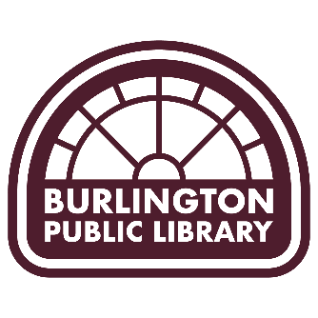

Agenda and Notification of Meeting
Posted: April 10, 2026

The Library Board will meet on Wednesday, April 15, 2026, at 4:30 p.m.
Create Space, Burlington Public Library 210 Court St.

Pursuant to Iowa Code 21.8 electronic participation in the meeting is offered to any Library Trustee upon request.

Agenda:
- Convene
- Roll Call

  - Jennifer McMillan
  - Becky Godfrey
  - Mary Weinand
  - Roger Hatteberg
  - Brandon Orth
  - Amanda Mansheim
  - Todd Chelf

- Approval of April 15th agenda and March 18, 2026 minutes
- Communication, Correspondence, & Public Address
- Board Training: Library Bill of Rights Interpretations
  - Review the 27 interpretations of the Library Bill of Rights linked above
- Approval of March 2026 expenditures
- Liaison Reports
  - West Burlington City Council: Rebecca Teater
  - Friends of the Burlington Public Library: Anita Wagner
- President’s Report
- Board Committees
  - Advocacy Committee Update
    - Approval of April 2, 2026 committee meeting minutes
  - Ad-hoc Nominating Committee
    - Discussion and action on nomination for board vacancy

- Discussion of March Library Services Report & Use Statistics
- Old Business
  - Union Update – Kathy Gerling
- New Business
  - FY27 Foundation Memo Update
- Adjourn

